**Folder Move**

**Summary:**

This document will explain how to move a folder.

**Step 1:** Double click **on Folder Move.zappy**, to start the execution**.**

**Step 2:** Run Zappy Task window will open on screen. Now Click on **OK** to execute the automation.

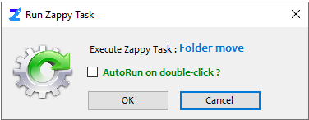

**Step 3:** After click on **OK,** Select the **folder** which you want move.

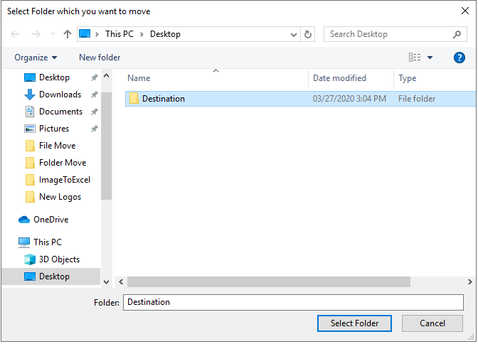

**Step 4:** Select the location where you want to save moved folder.

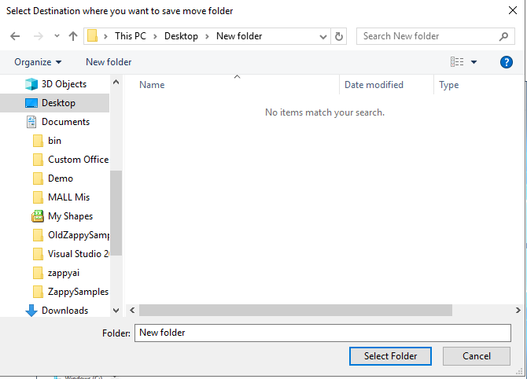

**Output:**

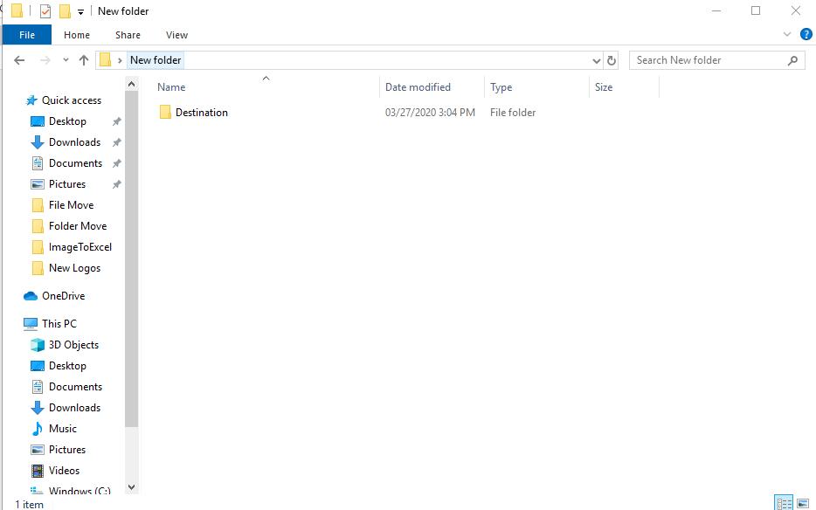

**In this way we can use this automation to move any folder.**